**Lab 09 Task**



**Name Hammad Arshad**

**Roll no SU92-BSAIM-F23-030**

**Section BSAI-4A**

**Subject PAI (LAB)**

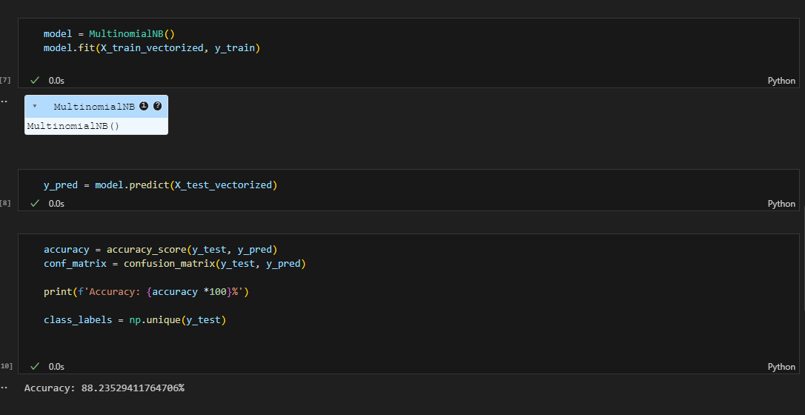

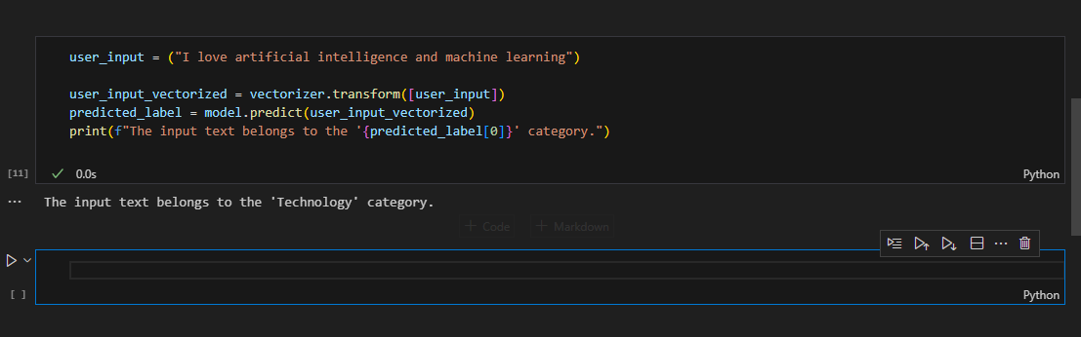

**1. How does this method work?**

The method first converts text into numerical data using **CountVectorizer**. Then, the **Naïve Bayes algorithm** analyzes word frequency patterns in different categories and predicts the most likely category for a given text.

**2. Why is Naïve Bayes used for text classification?**

Naïve Bayes is widely used because it is computationally efficient, simple to implement, and performs well even with relatively small datasets. Its assumption that words are independent simplifies probability calculations, making it a practical choice for text-based tasks.

**3. How does the model learn?**

The model learns by analyzing labeled text (**training data**) and counting the frequency of words in each category. It then uses probability calculations to predict the category of new text based on these patterns.

**4. What steps are involved in your project?**

1. **Load the dataset** from a CSV file.
2. **Split the data** into training and testing sets.
3. **Convert text into numerical features** using **CountVectorizer**.
4. **Train the Naïve Bayes model** on the vectorized text.
5. **Evaluate the model's accuracy** using test data.
6. **Use the trained model to classify new text samples**.

**5. How do you evaluate the model?**

The model is evaluated using metrics such as **accuracy score** and **confusion matrix**, which measure how well the model correctly classifies text. A higher accuracy score indicates better performance.

This structured approach ensures an effective text classification system using Naïve Bayes. Let me know if you need further refinements.